# ***Challenge Name :- Shorthand Sleuth***

**Description:** Welcome to the 2FA Challenge! This simulation emphasizes the significance of Two-Factor Authentication (2FA) in bolstering online account security. Your objective is to surpass both the login credentials and the 2FA code to gain access to both the user and admin dashboards, retrieving the flag along the way.

**Level:** Easy

**Solution:** In the 2FA Challenge, participants will demonstrate their understanding of Two-Factor Authentication (2FA) by bypassing login credentials and 2FA codes to access user and admin dashboards. By successfully retrieving the flag, participants will showcase their ability to navigate security measures and reinforce their knowledge of securing online accounts. In the main page, the importance of 2FA is emphasized.

Click on the link provided to access the login page.

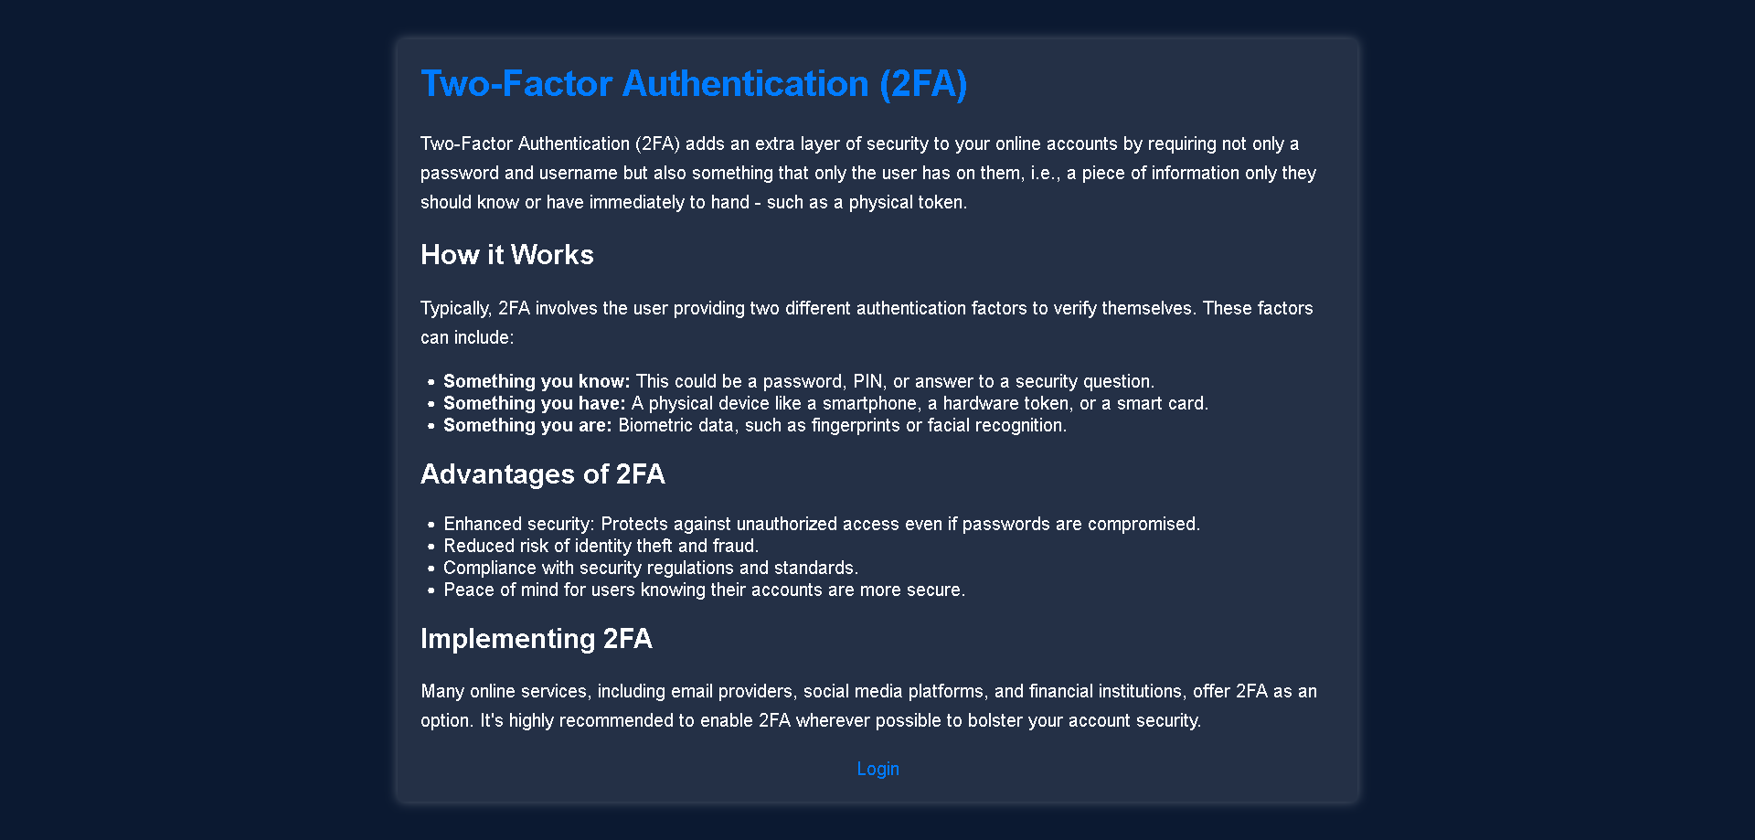

On the login page, attempt to brute-force the username and password combination. Use common usernames such as "admin" or "user" and try common passwords or use automated tools to speed up the process.

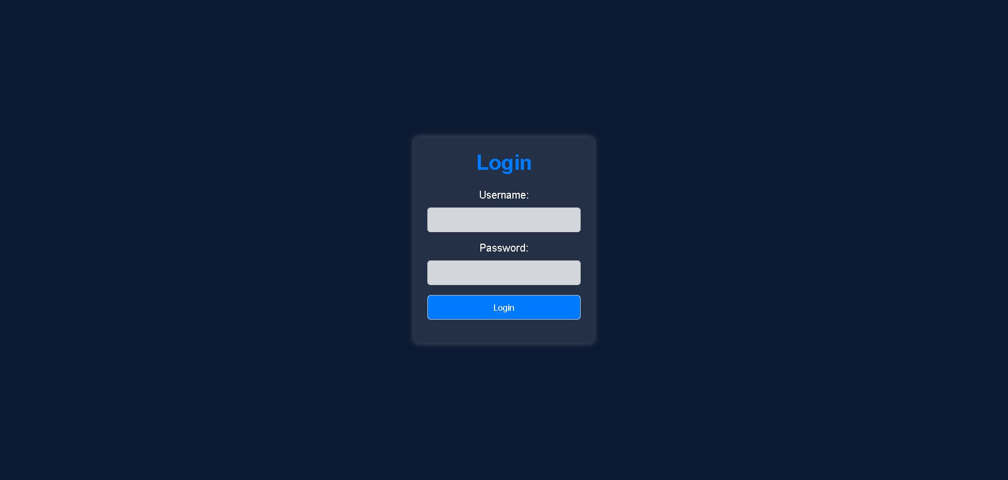

**Username – user**

**Password – userpass**

Once you successfully log in with valid credentials, the website will prompt you to enter a 2FA code.

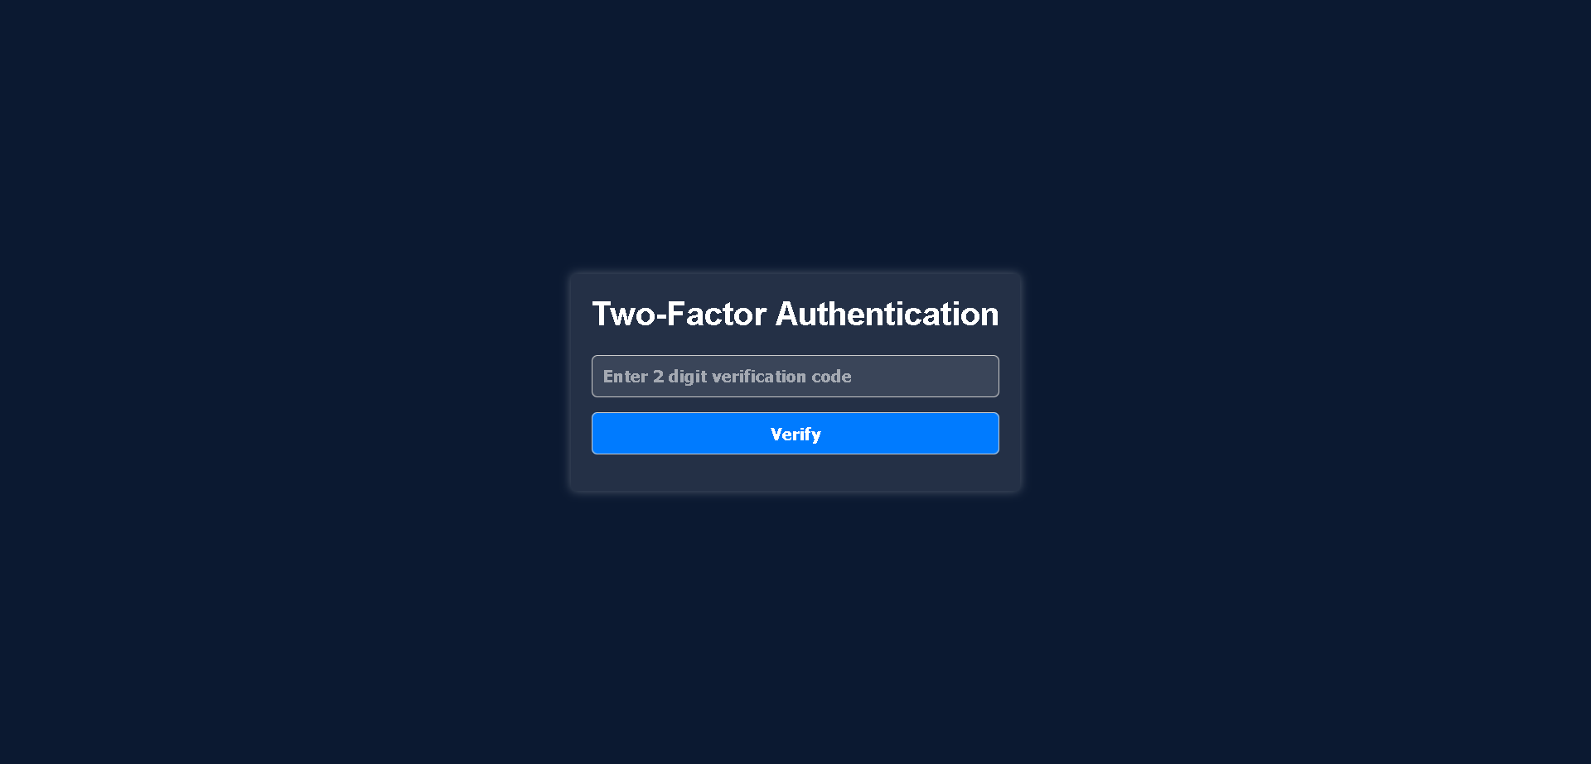

Begin brute-forcing the 2FA code. You can generate random codes or try commonly used ones.

**Code - 78**

After successfully bypassing the 2FA verification, you will be redirected to the user dashboard where you have to solve the captcha to get access to admin login page.

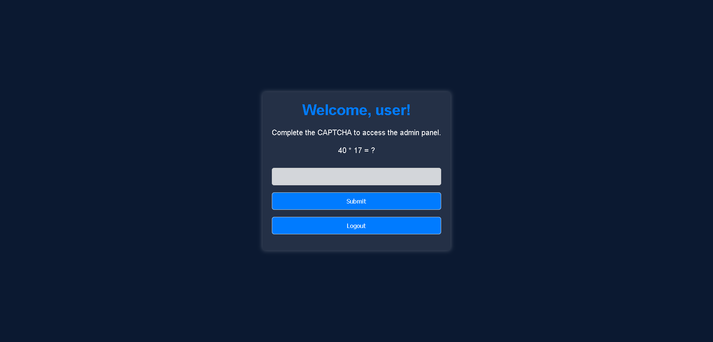

Solve the captcha.

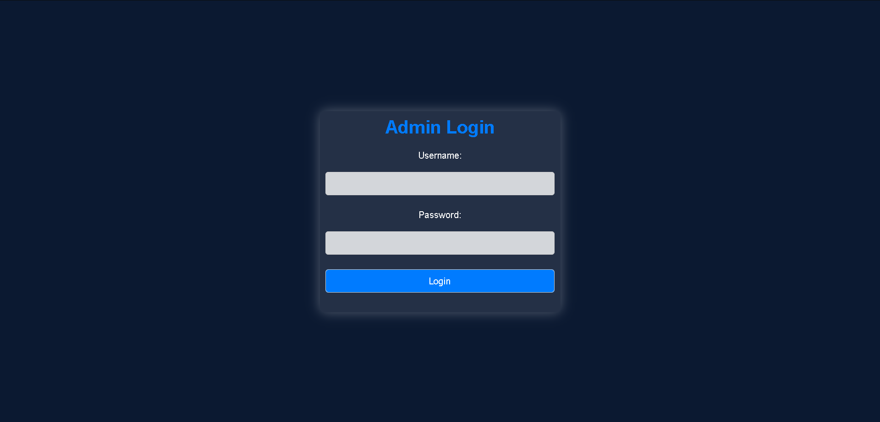

Now here, users have to think and bruteforce.

**username: admin**

**password: nimda**

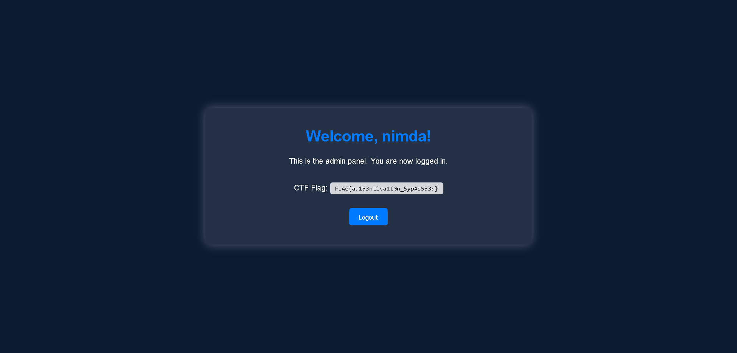

FLAG{au153nt1ca1I0n_5ypAs553d}

Once you believe you've found the flag, take a moment to validate your discover

Congratulations!

This page is intentionally left blank